FOR IMMEDIATE RELEASE
Tuesday, August 30, 2022

Shallow Water Blackout Prevention Partners with Michael Phelps Foundation
on New Public Service Announcement Around Underwater Fainting

Michael Phelps, Coach Bob Bowman, & Shallow Water Blackout Survivor Chandler Watson Help Draw Attention to the Dangers of Prolonged Underwater Breath-Holding

(South Portland, ME / Atlanta, GA) – Shallow Water Blackout Prevention, in partnership with the Michael Phelps Foundation, today announced the release of a new Public Service Announcement (PSA) that calls attention to the dangers of drowning due to prolonged underwater breath-holding, commonly known as Shallow Water Blackout (SWB).

The Don’t Hold Your Breath PSAs feature Michael Phelps and SWB survivor Chandler Watson. The PSAs will premiere live on YouTube this evening, Tuesday, August 30th at 7pm (EST) with a Q&A featuring Hall of Fame Swim Coach and Michael Phelps Foundation Board Member, Bob Bowman, and Shallow Water Blackout Prevention Executive Director, Britt Jackson. (https://youtu.be/FeMOoz6RtdM)

“I was first introduced to swimming through a water safety program, and it’s been one of my goals to help every child learn to swim,” said Michael Phelps. “While swimming is a lifesaving skill, it’s still important - no matter who you are - to be careful around the water. I’m competitive and love to play games, especially in the pool, but I want everybody to know that there are some basic tips that apply to us all – never swim alone and never hold your breath for an extended amount of time. Shallow water blackout is lethal but also preventable, so please educate yourself and your loved ones about the importance of water safety.”

“No matter how strong a swimmer you are, holding your breath for an extended time underwater is extremely dangerous,” said Coach Bob Bowman. “It may seem like it’s all fun and games in the moment but denying your brain oxygen can lead to shallow water blackout, which has a significantly high death rate (94%) as the time and ability to save somebody is extremely small.”

The Don’t Hold Your Breath PSAs are being released prior to the distribution of a new documentary short film by the same name, Don’t Hold Your Breath, which captures the dramatic retelling of Watson’s near-tragic story on a 4th of July vacation in 2020. (https://www.dontholdyourbreathfilm.com)

As Chandler recounts, “I was on a family vacation, and we were playing a few games in the pool trying to see how far we could all swim different strokes,” said Watson. “We tend to be a competitive family and we were having fun, so we decided to see how far we could swim underwater. I had made it down to the end of the pool and was on my way back when I started to struggle, then everything went black. If not for two doctors who happened to be nearby, I wouldn’t be here today as they literally brought me back to life. My family and I want to share our horrific experience to help educate others as this situation was completely avoidable. So please learn from me, don’t swim alone and don’t hold your breath for extended amounts of time.”

Shallow Water Blackout is an underwater “faint” due to a lack of oxygen to the brain that is brought on by holding one’s breath for an extended period. Regardless of swimming ability, SWB can affect anyone who is holding their breath underwater. From competitive swimmers to military services members, from snorkelers to spearfishers, from free divers to backyard pool or lake enthusiasts; SWB cuts across amateurs and professionals in any water environment (pool, lake, river, ocean, bath or hot tub) as no one is protected from a potential underwater blackout.

Shallow water blackout occurs without warning of its onset; because of hypoxia and detached mental state, one can feel euphoric and empowered to continue breath-holding. However, unlike traditional drowning where there may be six to eight minutes before brain damage or death may occur, shallow water blackout is a result of the brain being denied oxygen and it only takes approximately two minutes for brain damage to set in and death shortly thereafter.

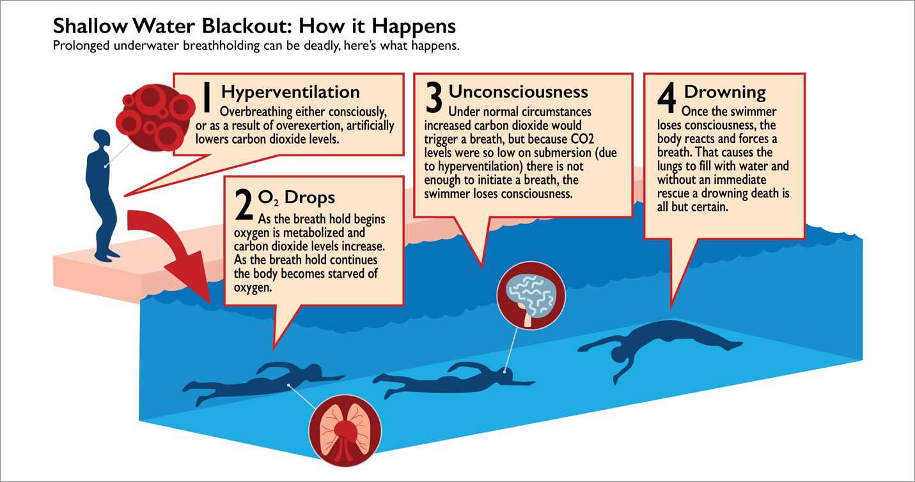

The Don’t Hold Your Breath PSAs will be available via Shallow Water Blackout Prevention (https://www.shallowwaterblackoutprevention.org) and the Michael Phelps Foundation (https://michaelphelpsfoundation.org)

ABOUT SHALLOW WATER BLACKOUT PREVENTION:
After the death of their son, Gene Whitner Milner, III in 2011, the Milner family formed the non-profit organization Shallow Water Blackout Prevention. The organization exists as a hub of information and educational resources for aquatics professionals, coaches, and the public at large to access freely. Their mission is to prevent more senseless deaths due to SWB through awareness and education.
ABOUT THE MICHAEL PHELPS FOUNDATION:
The Michael Phelps Foundation (MPF) is focused on promoting water safety, healthy living, and the pursuit of dreams, especially for children. Founded in 2008, MPF has provided learn-to-swim, healthy living, and goal-setting programming to more than 100,000 children and young adults around the world through strategic partnerships with the Boys & Girls Club of America, Special Olympics International, and the Level Field Fund. For more information, please visit: http://www.michaelphelpsfoundation.org.

